

Supplier Contract©
For [Project Name]

Document Control

Document Information
© | Information
Document Id | [Document Management System #]
Document Owner | [Owner Name]
Issue Date | [Date]
Last Saved Date | [Date]
File Name | [Name]

Document History
Version | Issue Date | Changes
[1.0] | [Date] | [Section, Page(s) and Text Revised]

Document Approvals
Role | Name | Signature© | Date
Project Sponsor

Project Review Group©

Project Manager

Quality Manager
(if applicable)

Procurement Manager
(if applicable)

Communications Manager
(if applicable)

Project Office Manager
(if applicable)

Table of Contents

Template Guide 1
1 Introduction 2
1.1 Purpose 2
1.2 Recipients 2
1.3 Definitions 2
2 Deliverables 3
2.1 Products 3
2.2 Training 3
2.3 Documentation 3
2.4 Support 3
2.5 Schedule 4
3 Responsibilities 4
3.1 Supplier 4
3.2 Project 5
4 Performance 5
4.1 Criteria 5
4.2 Reviews 6
5 Pricing 7
5.1 Schedule 7
5.2 Invoicing 7
6 Terms and Conditions 8
6.1 Confidential Information 8
6.2 Termination 8
6.3 Disputes 8
6.4 Indemnity 8
6.5 Law 9
6.6 Agreement 9

Template Guide

What is a Supplier Contract?

A Supplier Contract is an agreement between the project team (“Project”) and an external supply company (“Supplier”) for the acquisition of a defined set of products to meet the procurement requirements of the Project. The Supplier contract is a legal document which is used as the basis upon which to make Supplier payments during the procurement cycle. The contract specifically defines the:

- Products (i.e. goods and services) to be produced by the Supplier
- Responsibilities of the Project and Supplier in acquiring the products
- Review points to ensure that the acquisition is taking place as planned
- Pricing for each product acquired
- Invoicing and payments processes
- Terms and conditions applicable. ©

When to use a Supplier Contract

A Supplier contract should be used whenever a formal agreement is required between the Project and a preferred Supplier for the acquisition of product (i.e. goods and services) for the Project. A Supplier contract is usually documented in the last phase of the Tender Management Process, after the RFP proposals have been received and a preferred Supplier selected. After the Supplier contract is endorsed, the Procurement Management Process is initiated and the Supplier will then begin supplying the requisite products to the Project.

The Supplier contract is typically written by the Procurement Manager and approved by the Project Manager (or Sponsor). Without a formal Supplier contract in place, it may become difficult to formally control the procurement process. Also, the Project team (and Supplier) may become exposed to the risk that payment is defaulted owing to lack of customer satisfaction. A clearly written Supplier contract will mitigate this risk by outlining the deliverables and responsibilities of both parties to ensure that the Procurement Management Process takes place efficiently and fairly. ©

How to use this template

This document provides a guide on the topics usually included in a Supplier Contract. Sections may be added, removed or redefined at your leisure to meet your particular business circumstance. Example tables, diagrams and charts have been added (where suitable) to provide further guidance on how to complete each relevant section.

Introduction

This section describes the purpose of the Supplier Contract and provides clear definitions of frequent terminology utilized throughout the document.

Purpose
Describe the purpose of the Supplier Contract. For example:

“The purpose of this document is to clearly outline the responsibilities of both the Supplier and Project in meeting the requirements laid down by the Statement of Work (SOW).” ©

Recipients
It is important to describe the recipient group who will receive this Supplier Contract as the receipt of a copy of the formal signed contract initiates their obligations under the contract.

Definitions
Provide definitions for some of the key words used in this document which may have an ambiguous meaning by completing the following table:

Term | Definition©
Supplier | Supplier Company name, a duly incorporated company with a head office based in Supplier address.
Project | Project, a formally established project owned by Business name based in Supplier address.
Deliverable | “Deliverable” means a suite of products and other offerings provided by the Supplier and defined within Section 2 of this document.
Product | “Product” means an item to be delivered by the Supplier and defined within Section 2.1 of this document.
General | Words used in singular shall include the plural definition and vice-versa.

Deliverables

This section clearly outlines the deliverables to be produced by the Supplier to meet the full requirements of the Statement of Work (SOW).

Products
List the products to be provided by the Supplier to the Project team, as follows:

Product:

- Name
- Description
- Components (if a physical ‘good’)
- Activities (if a ‘service’ product)
- Quantity (i.e. the number of each particular product proposed)
- Purpose (i.e. its usage)
- Capabilities
- Quality. ©

Note: This section is the most critical section in the Supplier contract. It is important to stress that specific information must be provided to ensure that the product delivery requirements are clear and unambiguous.

Training
List the training to be provided by the Supplier to the Project team, as follows:

- Products for which training will be provided
- Method of training (e.g. one-to-one, classroom, train-the-trainer)
- Level of training to be given (e.g. beginner / intermediate / senior)
- Number of trainees to be given training.

Documentation
List the documentation to be provided by the Supplier to the Project team, as follows:

- Products for which documentation will be provided
- Actual documents to be generated
- Depth of each document provided
- Target audience for each document provided.

Support
Describe the support to be provided by the Supplier to the Project team, as follows:

- Products for which support will be provided
- Types of support (e.g. 1st, 2nd, 3rd level support)
- Response times for support provided
- Hours for support provided
- Organizations involved in providing support. ©

2.5 Schedule
Provide a detailed schedule of the timeframes within which the deliverables must be received by the Project. For example:
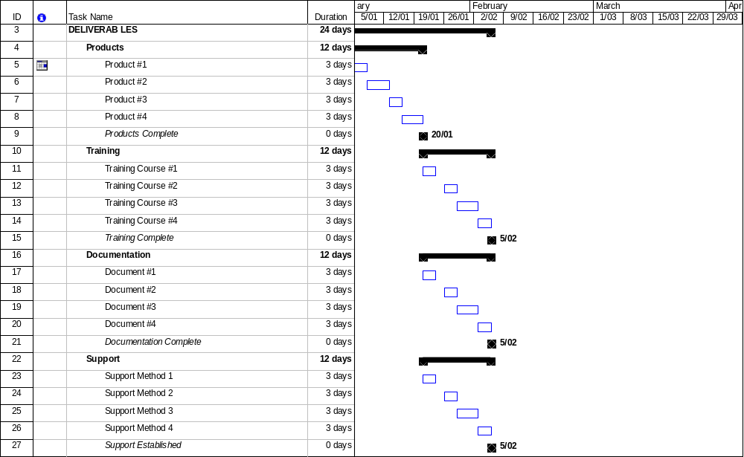

Responsibilities

This section describes the responsibilities of the Supplier and the Project in producing and receiving the above deliverables.

Supplier
List the responsibilities of the Supplier. For example, the Supplier is responsible for:
- Producing / supplying the product for review and acceptance by the Project
- Providing product which meets the requirements outlined in Section 2
- Notifying the Project if there are likely to be delivery issues resulting in a delay
- Informing the Project if there are likely to be any changes to the product supplied. ©

Project
List the responsibilities of the Project. For example, the Project is responsible for:

- Formally notifying the supplier of the receipt of each product
- Reviewing each product against the specifications laid out in Section 2
- Formally notifying the supplier of the acceptance of each product
- Informing the Supplier if there are likely to be any changes to the product required. ©

Performance

This section clearly outlines the criteria and process for reviewing the performance of the supplier during the procurement process.

Criteria
List the criteria under which the performance of the supplier will be measured, as follows:

Criteria | Description©
Completeness | Supply of the complete set of products as stated in Section 2 of this document. Each product must be provided in its entirety without compromise.
Quality | Each product must meet the quality standards defined in Section 2 of this document. Furthermore, each product must be ‘fit for purpose’.
Quantity | The total number of each product (as defined by Section 2 of this document) must be provided to the Project.
Timeliness | Each product must be provided within the scheduled delivery dates outlined by Section 2 of this document.

Reviews
Outline the process and schedule for reviewing supplier performance throughout the execution of this contract. For example:

The process by which supplier performance will be reviewed is as follows:

- The Project team will assess the product provided to date and determine whether or not it meets the requirements outlined by Section 2 of this document. Furthermore, the Project team will assess whether or not the general terms and conditions of this document (provided by Section 6) have been fully complied with
- If the review identifies a deviation between the expectations of the Project team and the actual Supplier's performance, a formal issue will be raised by the Project team and discussions will commence with the Supplier to identify an appropriate resolution.
- If a resolution is not possible, a dispute will be raised (see Section 6.3)
- Regardless of the outcome of the review, the Supplier will be notified by the Project team within 5 working days of the completion of the review. ©

The following schedule outlines the timeframes for review of supplier performance:
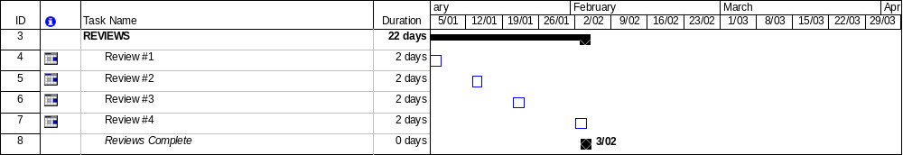

Pricing

This section clearly identifies the price to be paid for each deliverable provided by the Supplier. The invoicing and payments process is also highlighted.

Schedule
List each of the deliverables and their respective prices within the following table:

Deliverable© | Price / Unit
Products
- Product #1
- Product #2

Training
- Training Course #1
- Training Course #2

Documentation
- Document #1
- Document #2

Support
- Support Method #1
- Support Method #2

Note. For each price listed, it is important to explicitly state the currency (e.g. $US dollars) and units (e.g. per component or hour of time).

Invoicing
Describe the process to be undertaken to issue and approve supplier invoices for payment. For example:
- Invoices will be generated only for deliverables produced and accepted by the project
- Invoices will be submitted monthly and paid by the 20th of the following month
- Invoices will be dated on the last day of the month within which they were produced
- In the event of an invoice's being disputed, the Project shall pay the undisputed portion of any invoice and the matter in dispute shall be dealt with under Section 6.3 of this document. ©

Terms and Conditions

This section lists the terms and conditions to which both parties must adhere to successfully complete the contract.

Confidential Information
Identify how sensitive project information relating to this contract should be handled by the Supplier. For instance:

- During the course of this contract, you may acquire confidential information relating to our business, project and/or customers
- You agree to keep this information strictly confidential at all times (even after the project has been completed)
- You will not use or attempt to use it for your personal gain or the gain of any other person
- You may disclose confidential information only to the extent that such disclosure is necessary for the execution of your responsibilities under this contract
- This does not apply to information which must legally be disclosed or becomes available to and known by the public. ©

Termination
Describe the termination clause which may be invoked by either party to terminate the contract. For example:

This contract may be terminated by either the Supplier or the Project after 30 days written notice to the other party. The Project shall pay all Supplier invoices up to the date of Termination. From there on the Supplier shall be released from providing further deliverables referenced in Section 2 of this document unless those deliverables are currently in dispute.

Disputes
Describe the dispute clause which may be invoked by either party to formally raise a dispute under the contract. For example:

If an issue cannot be resolved through direct negotiation between the Supplier and the Project, a formal ‘Dispute’ must be raised and the other party notified of the dispute in writing. The matter in dispute shall be referred to and settled by arbitrator company or association name. The decision of the arbitrator shall be binding on both parties. Following the resolution of the dispute, both parties shall continue to undertake their responsibilities under this contract as if the dispute had not occurred.

Indemnity
Describe any indemnity clauses required by either party to this contract. An indemnity clause provides a party with legal exemption from damage, loss or injury caused to the other party. Furthermore, it negates or limits the possible compensation claimed for damage, loss or injury suffered by the other party. ©

Law
Specify the country for which legislation will govern the agreement. For example:

United States of America (USA) legislation shall govern this contract. Both parties consent to the jurisdiction of the USA courts.

Agreement
It is necessary to make the statement that this contract constitutes the entire contract between both parties and that it supersedes all other contracts, agreements or understandings previously or currently in existence. Only changes authorized in writing shall constitute a modification to this contract. ©

